5.1 Graphing Square Root Functions Practice

Graph the following equations and provide all required information.

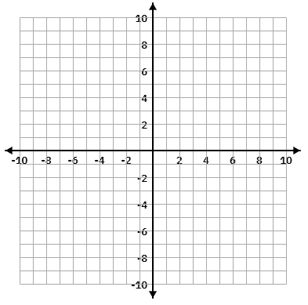

1. $f\left(x\right)= \sqrt{2x-6}+1$ 2. $y=-2\sqrt{-x-2}+4$

Domain:_______________

Range: _______________

Endpoint: _____________

Transformations:
Domain:_______________

Range: _______________

Endpoint: _____________

Transformations:



3. $f\left(x\right)= \sqrt{\frac{1}{2}x+3}-4$ 4. $f\left(x\right)= \sqrt{-2x+8}$

Domain:_______________

Range: _______________

Endpoint: _____________

Transformations:
Domain:_______________

Range: _______________

Endpoint: _____________

Transformations:



5. $f\left(x\right)= 3\sqrt{2x-6}-4$ 6. $f\left(x\right)=\frac{-1}{2} \sqrt{x+4}+2$

Domain:_______________

Range: _______________

Endpoint: _____________

Transformations:
Domain:_______________

Range: _______________

Endpoint: _____________

Transformations:



7. $f\left(x\right)=- \sqrt{x+2}-5$ 8. $f\left(x\right)=-2\sqrt{x-1}+3$

Domain:_______________

Range: _______________

Endpoint: _____________

Transformations:
Domain:_______________

Range: _______________

Endpoint: _____________

Transformations:



9. $y=3\sqrt{-x+2}-4$ 10. $y=-3\sqrt{\frac{1}{2}x+2}+2$

Domain:_______________

Range: _______________

Endpoint: _____________

Transformations:
Domain:_______________

Range: _______________

Endpoint: _____________

Transformations:

Write the equation from the given information.

11. If a graph has an endpoint of (-2, -7) and contains a point (2,-8), write its equation.

12. If a graph has an endpoint of (1, 4) and contains a point (10,13), write its equation.

13.If a graph has an endpoint of (-5, 1) and contains a point (4,-5), write its equation.

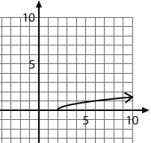
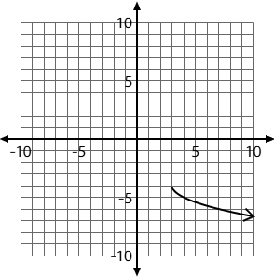
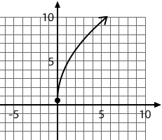
14. 15. 16.

